**AWS 101 API Gateway : Build an API with HTTP integration**

*Posted On July 10, 2019*

This section will help to setup resource, expose method on resource, configure method using method request and integration request to achieve desired API behaviour, test and deploy the API.

**Create an API**

Sign in to API Gateway console at <https://console.aws.amazon.com/apigateway>  
1. Click on Create API  
2. Next screen will show options to select from like , Choose the protocol, Create new API,

3. At Choose the protocol, select Rest  
4. To create an API, Choose Create new API and select New API  
5. Under Settings, provide an API name and description. Choose Regional as endpoint type.

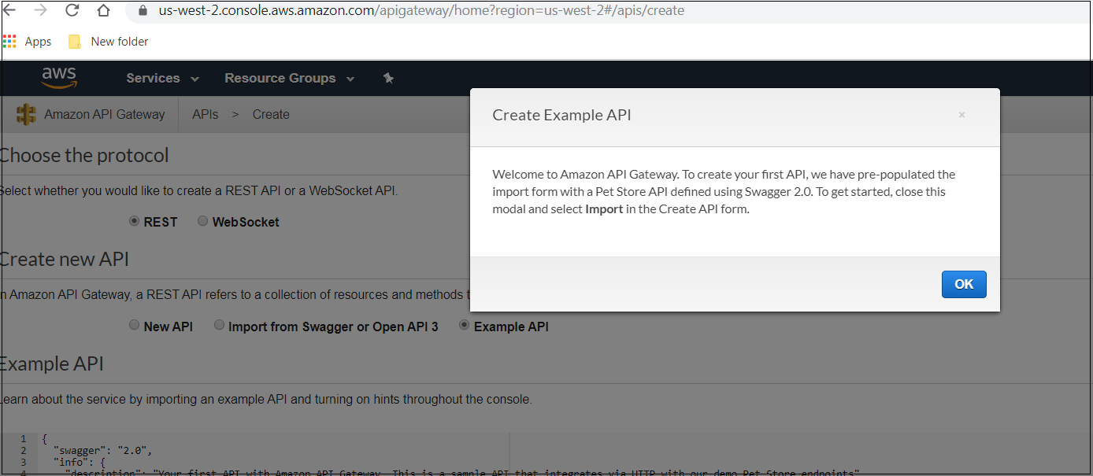

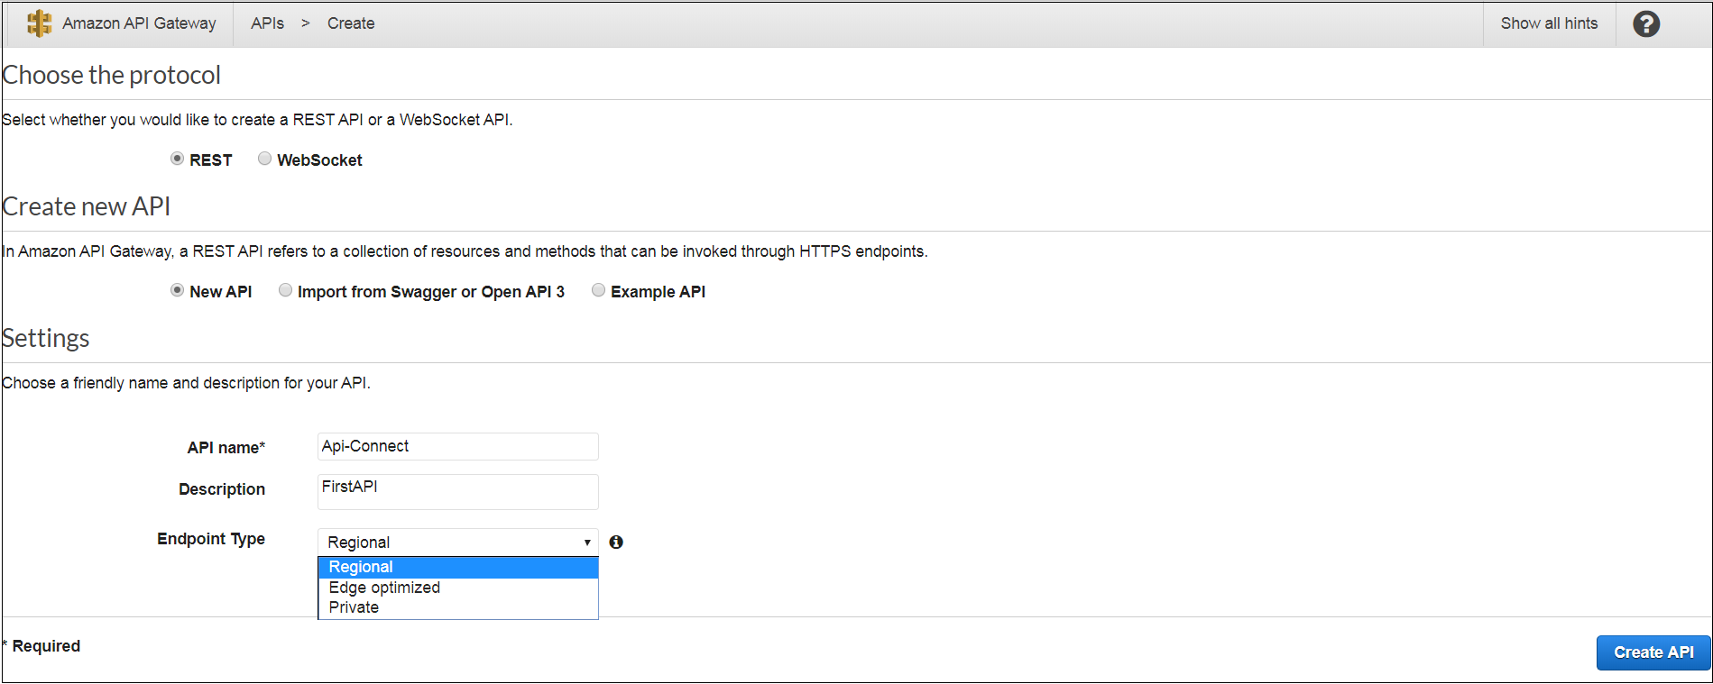

**Allocating resources and exposing its method**

The screen shows API-Connect(name of API) having resource, Stages, Authorizers, etc.  
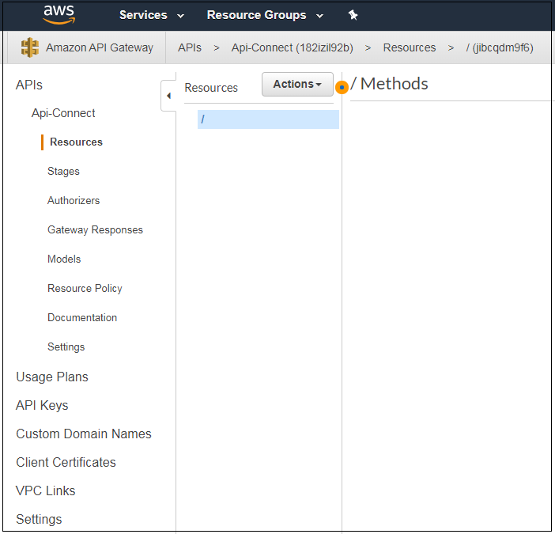  
1. To create resource, select root (/), click on Actions and then choose ‘Create Resource’. 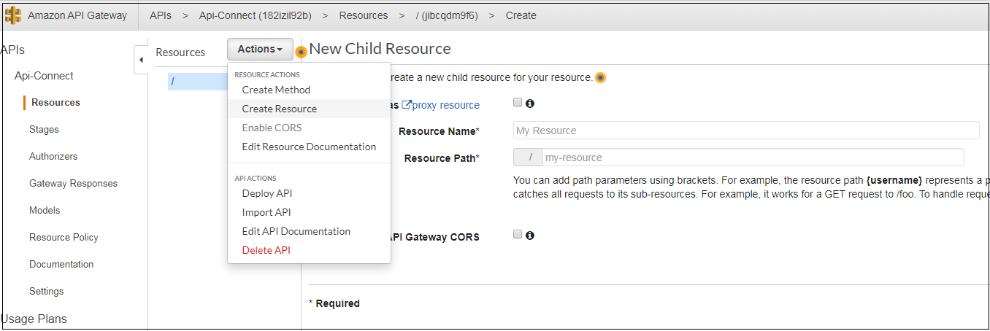  
2. Type resource Name, let defualt resource path as given. 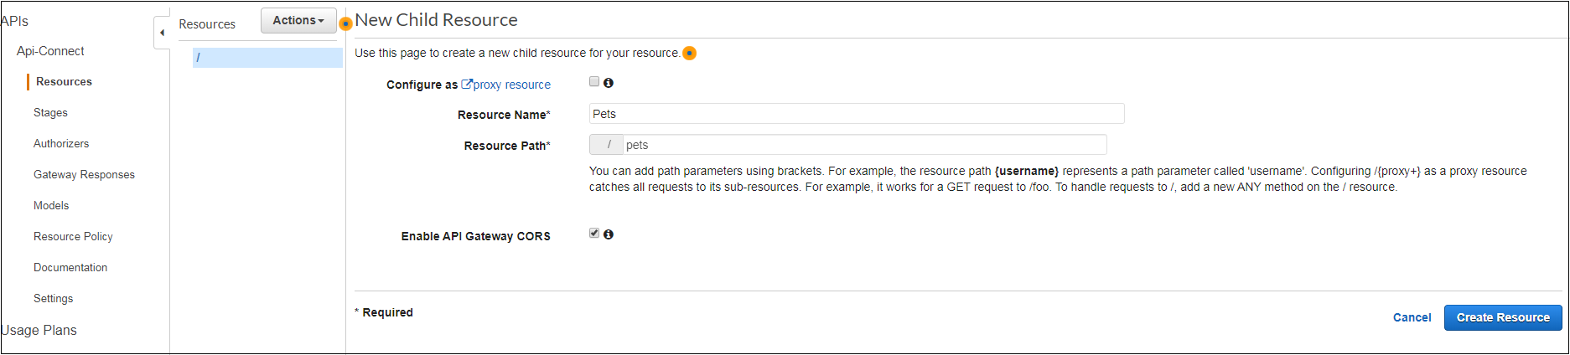  
  
3. To expose get method on Resource, choose Create Method from Actions menu.  
4. Choose get from the list by selecting tick mark.  
  
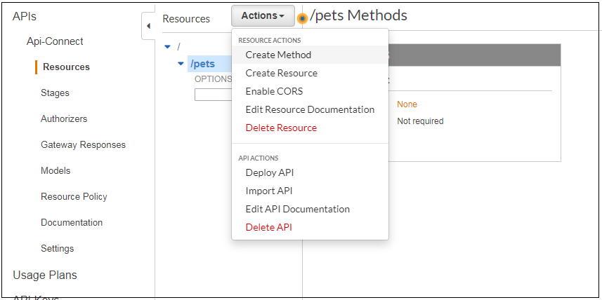  
5. In the method’s Get setup pane, select HTTP as Integration type.  
Select Http method as Get and type the URL of endpoint from where you would want to collect data and Save.  
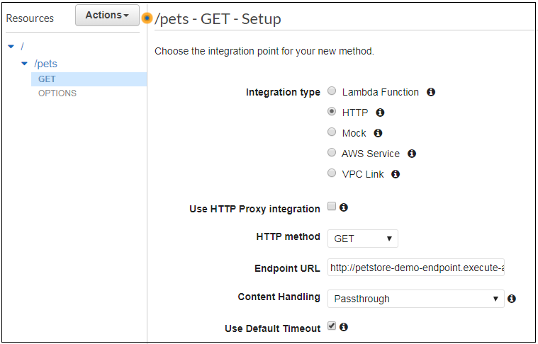

**Configuring Method**

The Get Method Execution Pane consists of Menthod Request, Integration Request, Method Response and Integration Response.

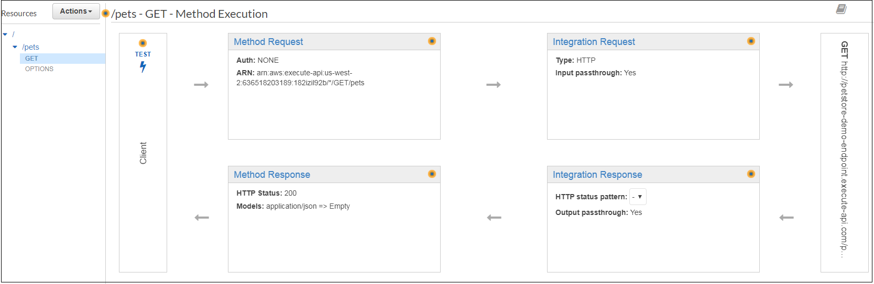

1. Choose Method Request, select AWS_IAM for **Authorization**, expand the **URL Query String Parameters** section, add query string parameters. Save Method Request.

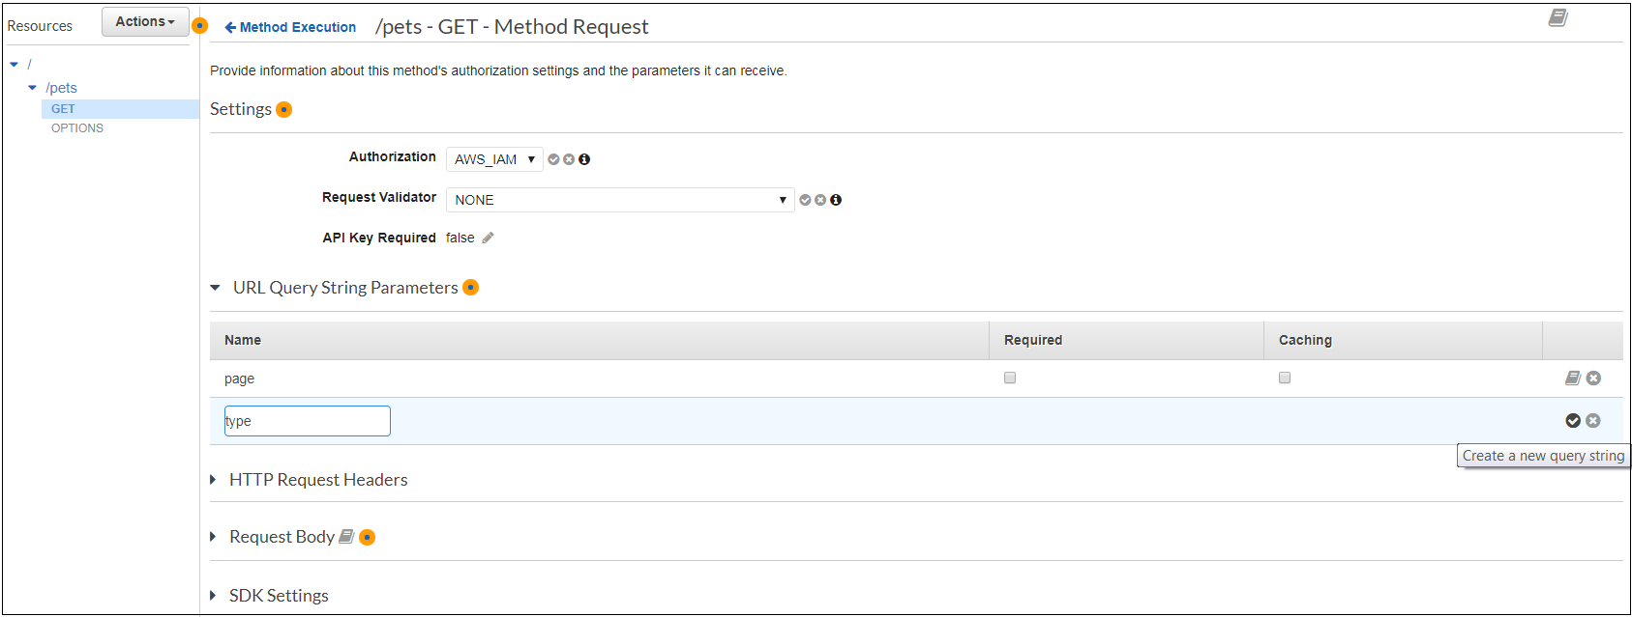

2. In the Get Integration Request, select HTTP as integration type. Expand URL query string parameters to find the default Method Request mapping already defined. This completes building API for demo.

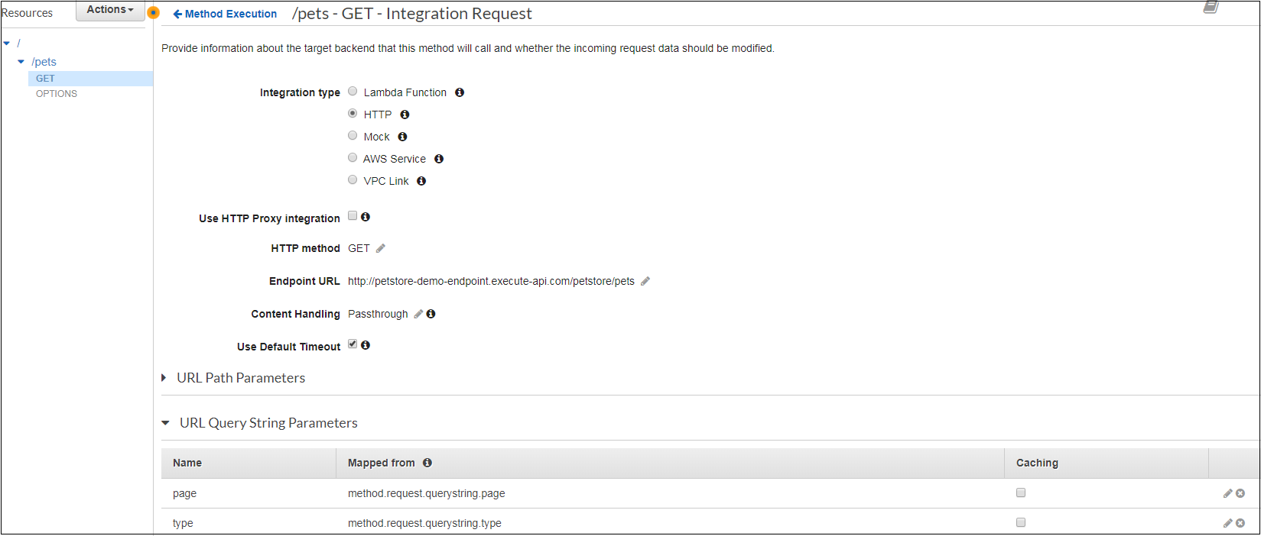

**Test and Deploy**

1. To test the API using the API Gateway console, choose **Test** on the **Method Execution** pane for the GET /pets method. In the **Method Test** pane, enter Dog(entered parameter) and **2** for the **type**( (entered parameter) and **page** query strings, respectively, and then choose **Test**.

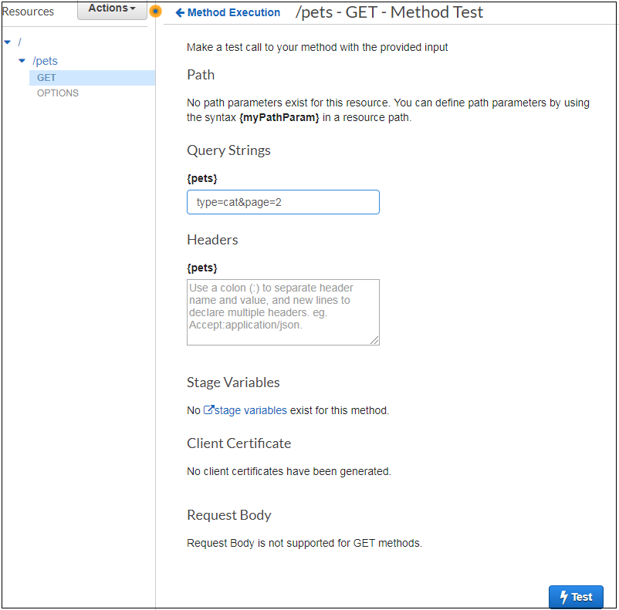

Click on Test

Result follows as shown in below image.

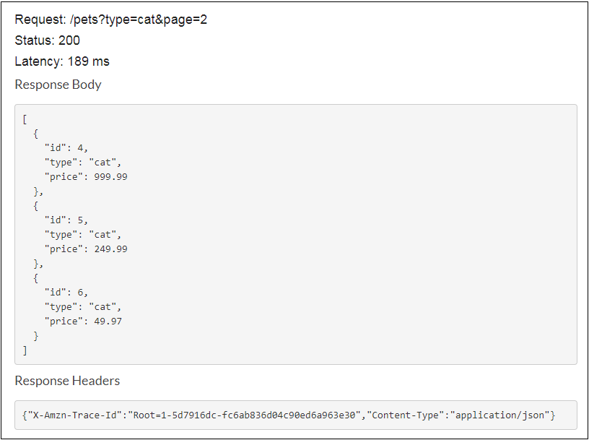

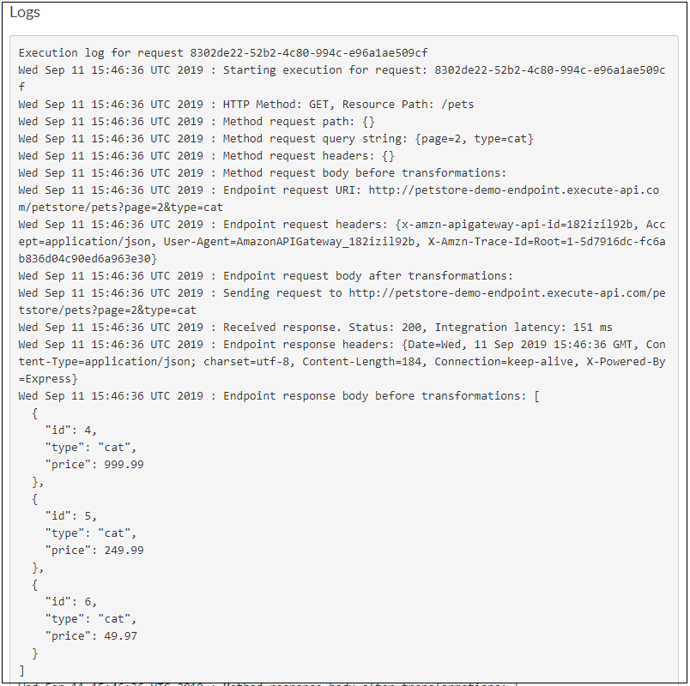

2. For deploying API, select the API and then choose **Deploy API** from the **Actions** list.

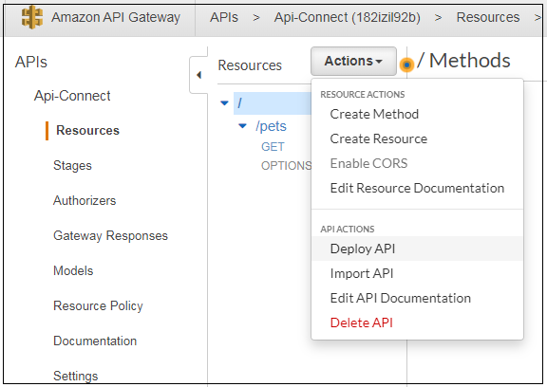

3. In the Deploy API, choose a stage, (can be New Stage for First Deployment), enter stage name and description, enter deployment description and click on Deploy.

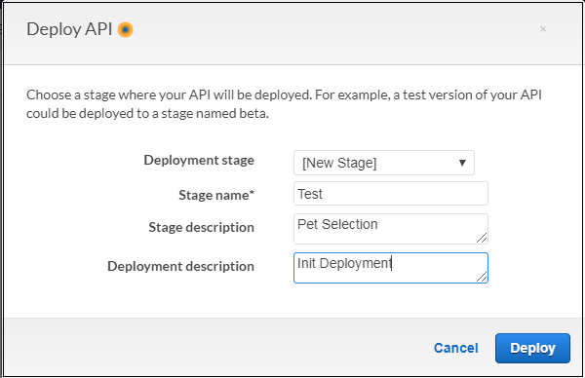

4. URL will get generated, invoking it by clicking it will open browser window where query parameters needs to be specified.

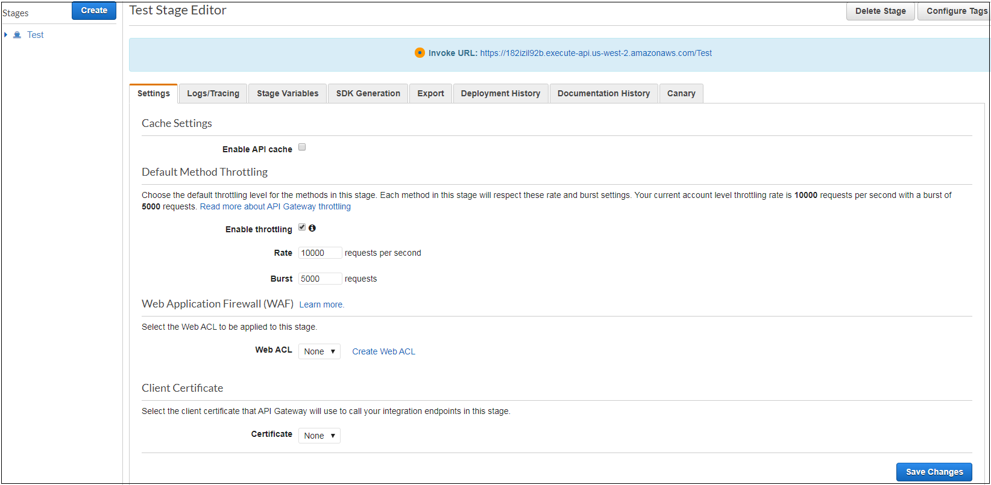

5. On Enter/ Return, you would get JSON-formatted response body, as shown in image below.

